COMP 550 HW 6C

Tye Zasacky

Collab: None

Proofs:

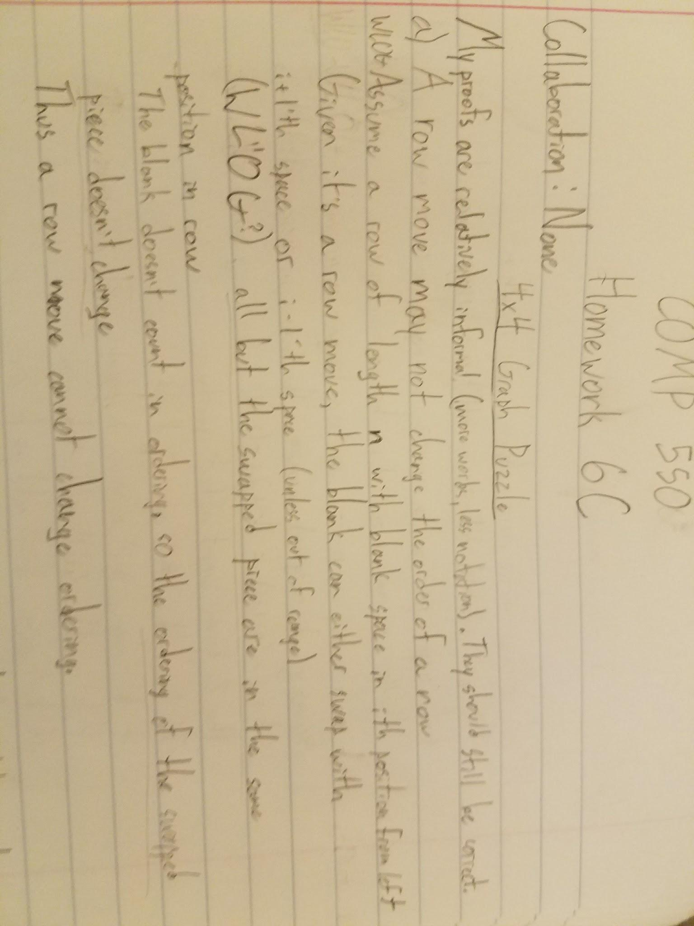

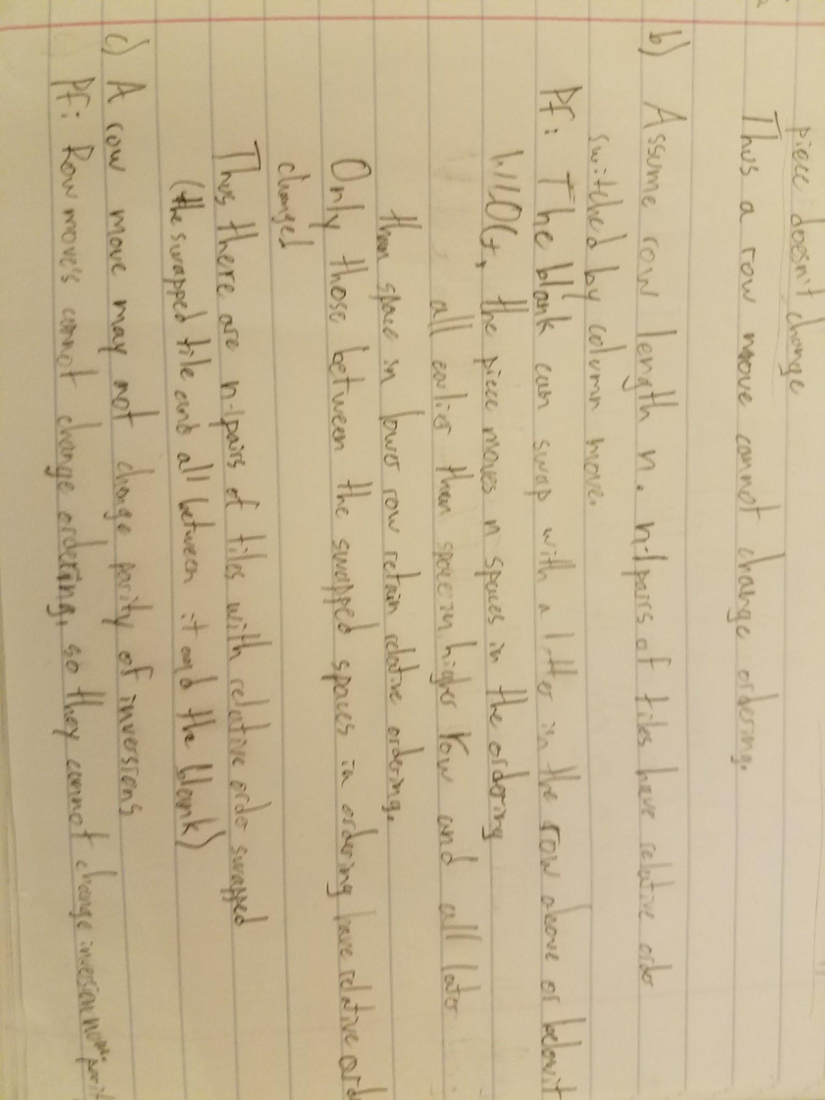

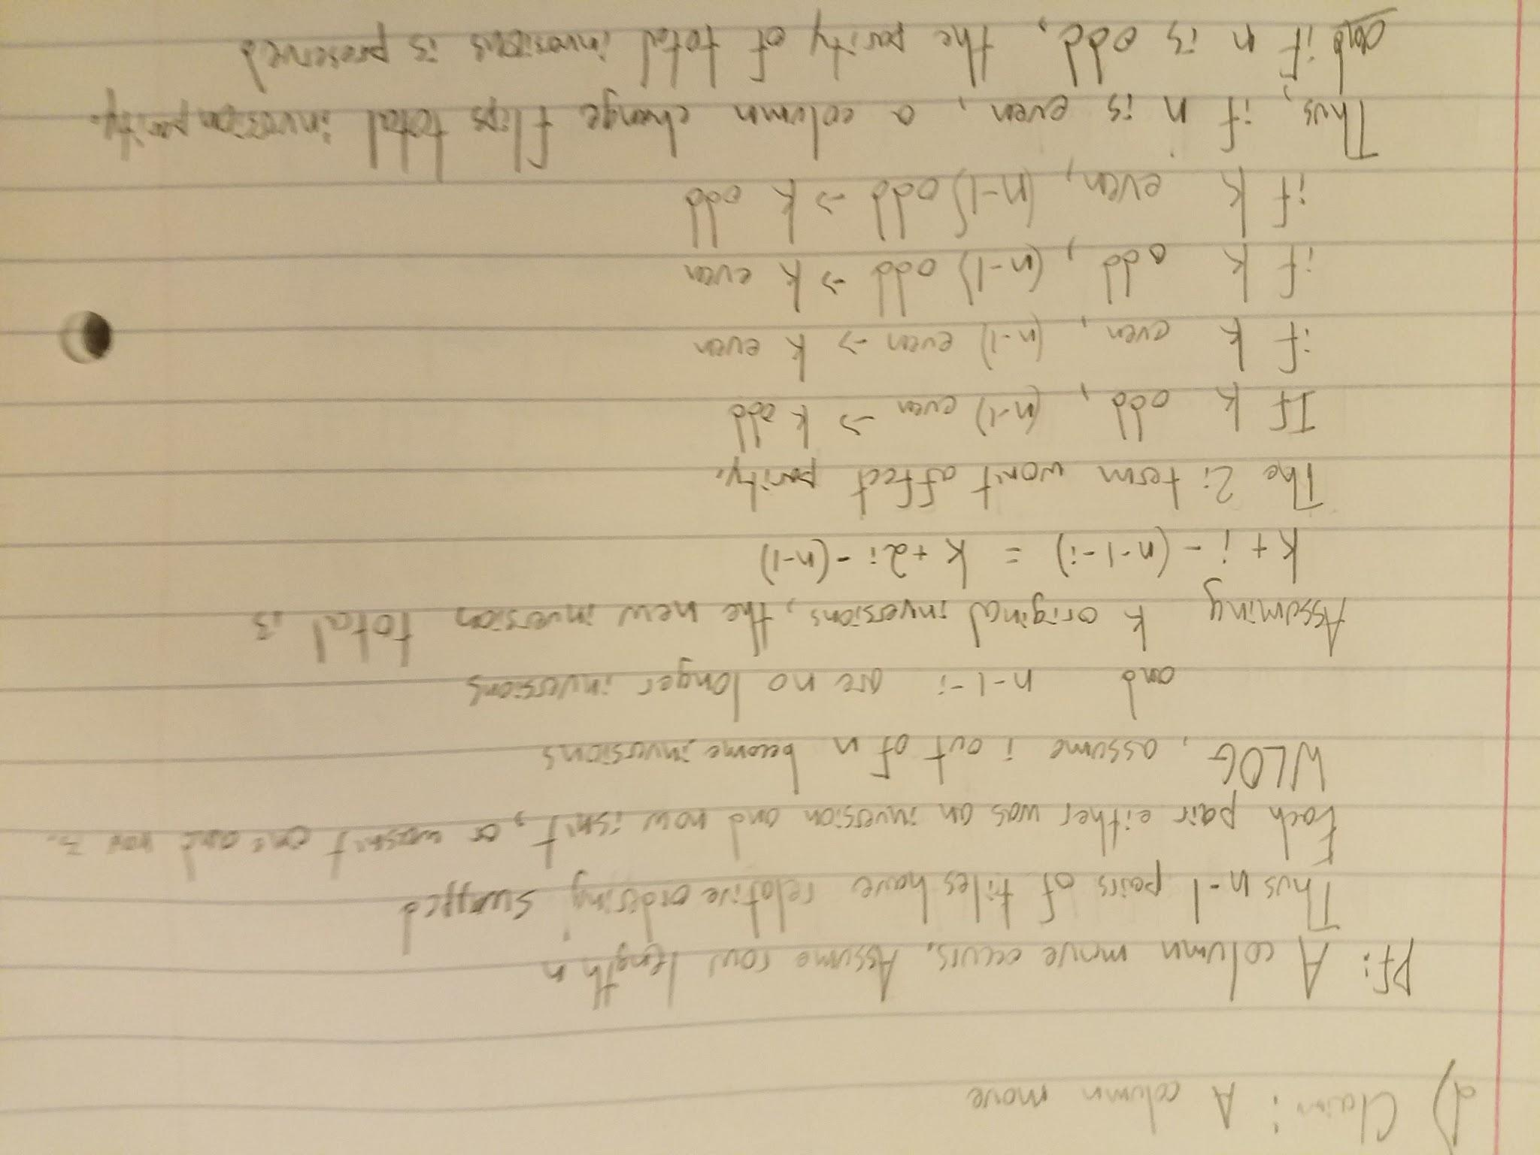Code: Attached

Implemented: isSolvable(), getInversionCount(), getBestMoves(), getBestMovesBidirectional()

Time Table:

|  |  |  |
| --- | --- | --- |
| Puzzle Moves | getBestMoves() time (ms) | getBestMovesBidirectional() time (ms) |
| 2 | 0.652171 | 0.617104 |
| 4 | 0.90021 | 1.013111 |
| 6 | 3.762066 | 1.773478 |
| 8 | 13.388541 | 7.147797 |
| 10 | 29.364383 | 37.502197 |
| 12 | 75.039034 | 21.769689 |
| 14 | 424.957759 | 124.065204 |
| 16 | 5004.330844 | 1422.15663 |
| 18 | 49304.404444 | 468.821726 |